NAME: Dave Nearing CS466-001
CHAPTER: 4
LAB: 1

For each chapter, you will complete a set of Animated Flashcards, Book exercises, and Lab exercises. Although you will have three different activities, you will submit them in one document. Use this document to record your answers for submission.

ANIMATED FLASHCARDS

In order to receive any point value for the Book and Lab exercises, you must submit your answers to the chapters corresponding eLearning module or the course schedule for the assigned chapter exercises. Identify your responses to the exercises by including their numbers as they appear in the chapter in this section.

1. Transistor
2. Adder
3. Circuit
4. Gate
5. Combinatorial circuit
6. Full adder
7. Sequential circuit
8. Circuit equivalence
9. Semiconductor
10. Truth table
11. Half adder
12. Multiplexer
13. Logic diagram
14. Integrated circuit (chip)
15. Boolean algebra

1. A
2. B
3. B
4. A
5. B
6. A
7. B
8. B
9. B
10. A
11. A
12. A
13. B
14. A
15. B
16. A
17. A
18. F
19. A
20. D
21. C
22. B
23. E
24. F
25. A
26. D
27. C
28. B
29. E
30. 0 <= n <= 2 is a 0
2<n is a 1
34. Gates can take multiple inputs and only produce one.
53. You use the output of a gate as the input for the next gate. You can also use the same input for different gates.
58. A-|>o-
)>--
B-|>o- |
=)>--X
C-|>o- |
)>--
D-|>o-

!!!
NOTE: I'm using the following logical notation:
AND = +
OR = v
NOT = ~
XOR = (+)
!!!
59. A B AvB A+B AvB + (A+B)

0 0 0 0 0

0 0 1 1 1

0 1 0 1 1

0 1 1 1 1

1 0 0 1 1

1 0 1 1 1

1 1 0 1 1

1 1 1 1 1
60. A B ~A A+B
~A(+)A+B
0 0 1 0 1

0 1 1 0 1

1 0 0 0 0

1 1 0 1 1

61. A B C ~A B(+)C ~A+(B(+)C)
0 0 0 1 0 0
0 0 1 1 1 1
0 1 0 1 1 1
0 1 1 1 0 0
1 0 0 0 0 0
1 0 1 0 1 0
1 1 0 0 1 0
1 1 1 0 0 0
62. A B C A+B B+C ~C (A+B)v~C ((A+B)v~C)v(B+C)
0 0 0 0 0 1 1 1
0 0 1 0 0 0 0 0
0 1 0 0 0 1 1 1
0 1 1 0 1 0 0 1
1 0 0 0 0 1 1 1
1 0 1 0 0 0 0 0
1 1 0 1 0 1 1 1
1 1 1 1 1 0 1 1
63. Circuit equivalence is when two circuits produce the exact same output for each input value combination.
69. A chip is a silicon wafer with a bunch of gates embedded in it.
73. (AvB)+(~(A+B))
LAB EXERCISES

The Lab Exercises are found on the textbook companion web site by clicking Explorations in Computer Science link, located in the left-side panel. Refer to the chapters number as you record your responses in this section.

1.

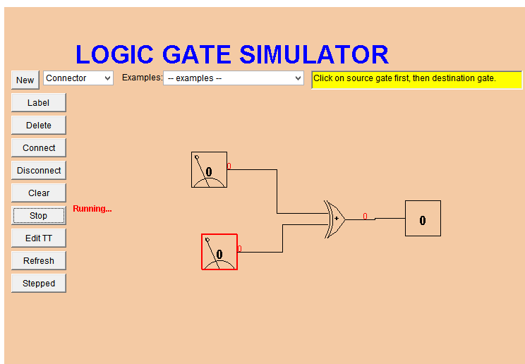

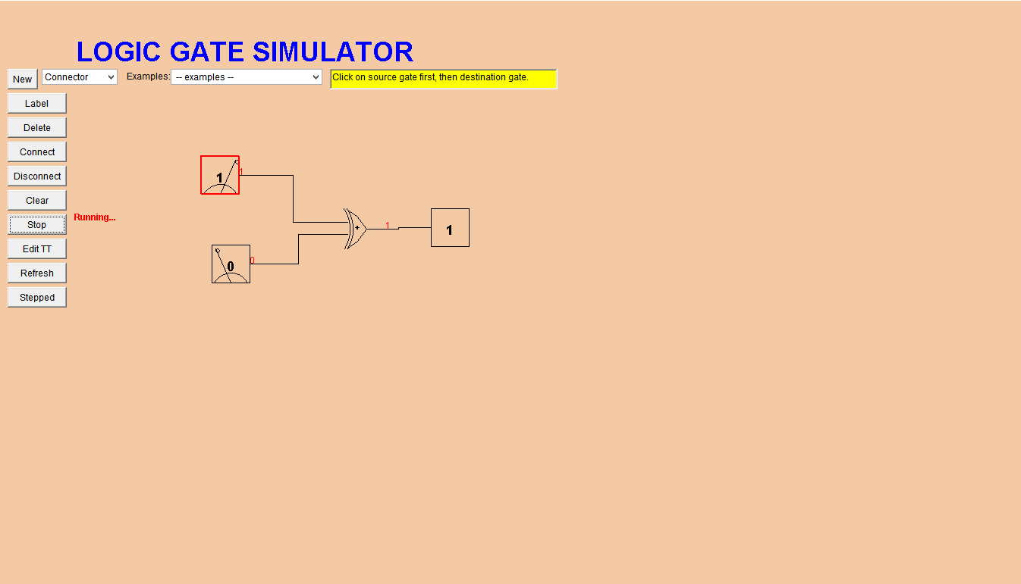

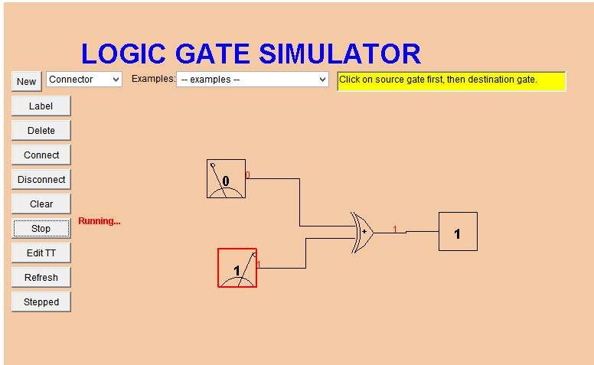

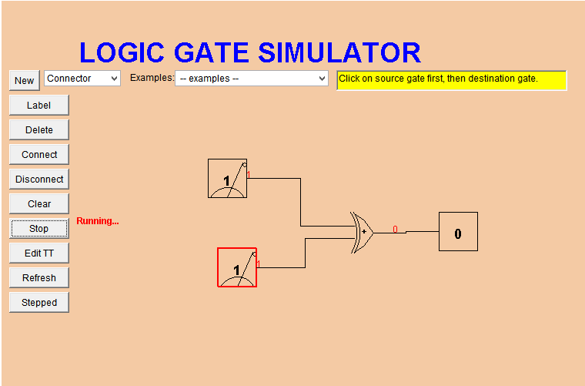
1.3. A B A(+)B
0 0 0
1 0 1
0 1 1
1 1 0

2.3. A B A(+)B ~(A(+)B)
0 0 0 1
1 0 1 0
0 1 1 0
1 1 0 1
It inverts the XOR. Only fires when A and B are different.
3.
